

ACE View ASPAC

Test Summary Report

**Version 1.1**

Table of Contents

1.0 Test Completion Summary 3

2.0 Program Details 4

3.0 Test Results 4

3.1 Details of Builds / Runs 4

3.2 Planned vs Actual Build Schedule 4

3.3 Test Execution Summary 5

3.4 Component Stability – Heat Map 6

3.5 ACE View Transaction/Flow Status 7

3.6 Open Defects Summary 8

3.7 Closed Defects Summary 12

3.8 Key Metrics 13

3.9 Best Practices and Automation 13

4.0 Test Deliverables 13

4.1 Test Documents Delivered 13

4.2 Desktop Configurations 13

4.3 Environmental Challenges 14

4.4 UAT Support from SIT 14

5.0 Appendix 15

5.1 Usecases Test execution Summary 15

5.2 CR Test execution Summary 15

5.3 UI Imperfections 15

5.4 Open Defects 15

6.0 Reference Documents 19

6.1 Requirement Document 19

6.2 Usecase Document: 19

6.3 CR Document: 19

# Test Completion Summary

The objective of this document is to provide an assessment of the testing effort performed for ACEView ASPAC project. The assessment describes the test results along with the test metrics, discrepancies, limitations and constraints encountered during testing.

**Test Execution Summary:**

* System test execution completed for SIT with Zero P1 and 5 P2 defects.
* Test execution was completed Zero % Deviation with respect to Schedule in 1A, 1B & E2E; 5% Schedule Variation observed in 1C due to Environment and DB issues
* End to End Testing was completed on 04th June with 100% execution and 95% pass. Final Regression planned to complete on 12th June.

**Test cases – Execution:**

* 2497 Test case Created and Executed; 2410 Passed, 80 Failed and 7 NA at the end of the execution.-Cumulative
* Overall 97% Pass Rate Observed. (Across cycles - Cumulative)

**Open Defects Summary:**

* Zero P1 Defects
* 5 P2 Defects Open (By Priority)
* 78 P3 and 97 P4 Open (P3 to Fixed during UAT cycle based on the fix capacity)

**Automation:**

* 70% of the Core Regression Test cases were automated that includes
* ASPAC Workflow - PO, T&E and CD creation.
* Workbasket - Perform Pend/Un Pend/Priority change
* Barcode Generation
* Notes - Alert/User/Diary
* ICC Component and Verification of Data Cap Scanned Documents in ACE View

**Out of Scope:**

* UI standards validation ( Few of the UI imperfections are listed in the appendix section)
* MI Report- Separate report would be published after reports testing
* Performance Testing- Separate report would be published at the completion
* Requirement #12,464.517has be excluded. Please refer the deferred sections for the details on these requirments.

**Overall Summary:**

**Following parameters are considered for the sign off from SIT,**

* System integration testing is completed for all the use cases/components (Refer Test execution summary-Appendix attached)
* System integration testing is completed for the CRs (Refer appendix for details)
* Test execution coverage is >95% (Exit criteria is >90%
* Cumulative Pass % of 97% (Exit criteria was defined at >90%)
* 5 P2 defects – All the defects has workarounds to complete the transactions
* 78 P3 and 94 P4 Defects open - These defects are not blockers for the completing the transactions.

Based on the above results in SIT, test team is providing a **Conditional Sign off** to move the code into UAT with known open defects as mentioned in the subsequent sections of this document.

# Program Details

|  |  |
| --- | --- |
| **#** | **Details** |
| **Release** | ACE View ASPAC Release 1 |
| **Duration** | 10 Months (Aug 2014 – Jun 2015) with test execution for 4 Months (Feb 2015 – June 2015) |
| **Type of Testing** | Functional Testing (SIT, End-End, Regression) and Automation Testing |
| **Environment** | SIT 2 |
| **Tools Used** | HP ALM and Selenium |

# Test Results

## Details of Builds / Runs

The test cases pass % is the cumulative pass% across the phases (1A, 1B, 1C and E2E cycles)

|  |  |  |  |  |  |  |  |
| --- | --- | --- | --- | --- | --- | --- | --- |
| **Release** | **Test Phase** | **Planned** | **Executed** | **Passed** | **Failed** | **NA** | **% Passed** |
| ASPAC | 1A | 592 | 592 | 589 | 1 | 1 | 100% |
| 1B | 791 | 791 | 773 | 18 | 0 | 98% |
| 1C | 634 | 634 | 591 | 37 | 6 | 94% |
| CR | 150 | 150 | 141 | 9 | 0 | 94% |
| End to End | 330 | 330 | 315 | 15 | 0 | 95% |
| **Total** | **2497** | **2497** | **2410** | **80** | **7** | **97%** |

## Planned vs Actual Build Schedule

|  |  |  |  |  |  |  |
| --- | --- | --- | --- | --- | --- | --- |
| **Release** | **Test Phase** | **Planned Start Date** | **Actual Start Date** | **Planned End Date** | **Actual End Date** | **Comments** |
| ASPAC | 1A | 27-Jan-15 | 27-Jan-15 | 19-Feb-15 | 19-Feb-15 | 0% Schedule Variation |
| 1B | 25-Feb-15 | 25-Feb-15 | 20-Mar-15 | 20-Mar-15 | 0% Schedule Variation |
| 1C | 30-Mar-15 | 30-Mar-15 | 17-Apr-15 | 30-Apr-15 | **5% Variation** Due to Environment unavailability, DB issues and Build delay |
| End to End | 8-May-15 | 8-May-15 | 4-Jun-15 | 4-Jun-15 | 0% Schedule Variation |

## Test Execution Summary

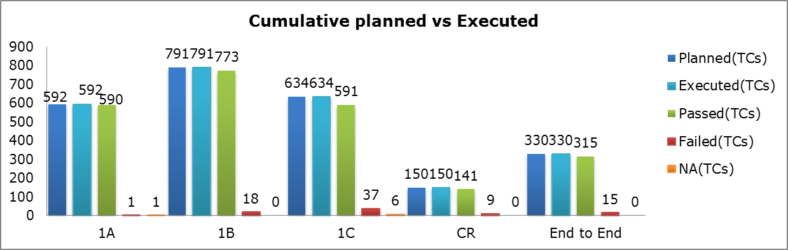

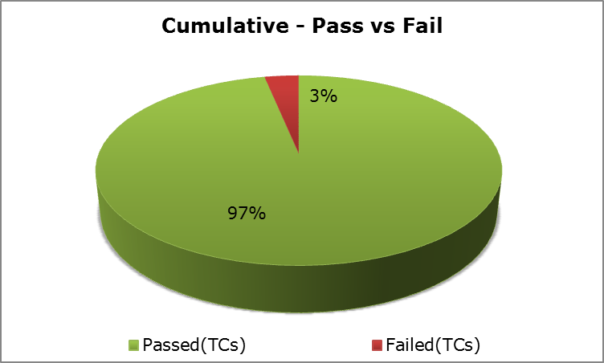

Note: The detailed test execution summary was available in the appendix section. Please refer appendix 5.1

## Component Stability – Heat Map

|  |  |  |  |  |  |
| --- | --- | --- | --- | --- | --- |
| **Stable Components:** | | | | | |
| **Components Stability Matrix - Heat Map** | **Test Execution %** | **Pass %** | **Overall Open Defects** | **Open P1 and P2** | **Component Stability** |
| Bar Code Generation | 100% | 100% | 5 | 0 |  |
| Email Broker | 100% | 98% | 1 | 0 |  |
| Datacap Scanning | 100% | 100% | 0 | 0 |  |
| Viewer Configuration | 100% | 100% | 0 | 0 |  |
| Document Generation | 100% | 100% | 4 | 0 |  |
| Send Email Build | 100% | 100% | 1 | 0 |  |
| ACEView Print | 100% | 94% | 1 | 0 |  |
| Upload Documents | 100% | 100% | 2 | 0 |  |
| Drag & Drop | 100% | 100% | 2 | 0 |  |
| Diary | 100% | 97% | 3 | 0 |  |
| Daeja - Security - Integration | 100% | 100% | 2 | 0 |  |
| Alerts & Notification | 100% | 95% | 3 | 0 |  |
| Workbasket | 100% | 95% | 13 | 0 |  |
| Notes | 100% | 96% | 4 | 0 |  |
| Send Fax | 100% | 100% | 0 | 0 |  |
| Security | 100% | 100% | 0 | 0 |  |
| Flags and Milestone | 100% | 100% | 0 | 0 |  |
| Manage User Preference | 100% | 98% | 1 | 0 |  |
| Email_ACEView Integration | 100% | 100% | 1 | 0 |  |
| Workflow Design | 100% | 100% | 1 | 0 |  |
| Scanning_ACEView Integration | 100% | 100% | 0 | 0 |  |
| **Partially Stable Component:** | | | | | |
| Correspondents | 100% | 90% | 4 | 1 (P2) |  |
| Security_ACEView Integration | 100% | 100% | 4 | 1 (P2) |  |
| ASPAC workflow | 100% | 97% | 16 | 1 (P2) |  |
| Open File and Open Case | 100% | 90% | 44 | 0 |  |
| Search Template | 100% | 84% | 27 | 0 |  |
| **Legends** | **> 90%** | **> 90%** | **< 10** | **0** | **Stable** |
| **< 90% & >70%** | **< 90% & >70%** | **> 10 & < 20** | **> 0 & < 5** | **Partially Stable** |
| **> 70%** | **> 70%** | **> 20** | **> 5** | **Unstable/Need Immediate Attention** |

* 2 P2 are not listed in the above section (Active x defect, and Creation of Blank PO’s) are they are generic defects.
* PeopleSoft integration is complete with all the test cases executed and 100% pass.
* The Components – Correspondents, Security_ACE View Integration, ASPAC workflow has P2 defects open.
* The components - Open File and Open Case and Search Template, have open defects (P3 and P4) greater than 20.
* But these defects will not have an impact creating End to End transaction.
* **No components are in red status.**

## ACE View Transaction/Flow Status

|  |  |  |  |
| --- | --- | --- | --- |
| **S.No** | **Transaction/Flow** | **Testing observations** | **Comments** |
| 1 | PO Creation | Functional (works fine) |  |
| 2 | T&E Creation | Functional (works fine) |  |
| 3 | CD Creation | Functional (works fine) |  |
| 4 | PO Document Generation | Functional (works fine) |  |
| 5 | Send Email from ACE View | Functional (works fine) |  |
| 6 | Send Fax from ACE View | Functional (works fine) |  |
| 7 | Ingest Email via ICC | Functional (works fine) |  |
| 8 | BarCode Generation | Functional (works fine) |  |
| 9 | Datacap Scanning | Functional (works fine) |  |
| 10 | Upload Documents into ACE View | Functional (works fine) |  |
| 11 | Drag and Drop documents | Functional (works fine) |  |
| 12 | ACE View Print | Functional (works fine) |  |
| 13 | Daeja Viewer | Functional (works fine) |  |
| 14 | File Search | Functional (works fine) |  |
| 15 | Creation of Dairy/Alerts/Notes | Functional (works fine) |  |
| 16 | Add User/Edit User | Functional (works fine) |  |
| 17 | Set Roles to User | Functional (works fine) |  |
| 18 | Manage Workbaskets | Functional (works fine) |  |
| 19 | Manage User Preference | Functional (works fine) |  |
| 20 | Updating Flags and Milestones | Functional (works fine) |  |
| 21 | Set Correspondents details | Partially Functional | P2 Defect id is 470 |
| 22 | Email Notification | Partially Functional | P2 defects- 778 and 1026 |

* For Save & Send and Drag & Drop active x need to installed, please contact IT environment team.
* Email notification is not triggered from ACE View and for the same P2 defects 778 and 1026 are open
* Correspondent details are not getting updated for PO files – P2 defect 470 is open
* All other transactions except above 2 are working in SIT (on the given date)

## Open Defects Summary

**Open Defects Summary by Priority**

|  |  |
| --- | --- |
| **Defects by priority** | **Total** |
| P1 | **0** |
| P2 | **5** |
| P3 | **78** |
| P4 | **94** |

Open defects does not include the defects in the status “Deferred”.

**P2 – Open Defects Summary:**

|  |  |  |  |  |  |  |  |
| --- | --- | --- | --- | --- | --- | --- | --- |
| **Environment** | **Defect ID** | **Summary** | **Planned Fix Date** | **Defect Status** | **Fix Priority** | **Defect Classification** | **Component Name** |
| ASPAC - SIT 2 | 470 | Correspondents : Vendor Correspondence Name and Address not getting populated correctly in Correspondent tab. |  | Open | 2 - High | Functional | Correspondents |
| ASPAC - SIT 2 | 778 | ASPAC Workflow: User with finance indexer role is not getting Email notification, when a work item remains in finance indexing work basket more than 48 hours as per the config. | 11/06/2015 | Open | 2 - High | Functional | ASPAC Workflow |
| ASPAC - SIT 2 | 962 | ACE View : An ActiveX Control pop up is displayed every time the user login into ACE View system. |  | Open | 2 - High | Environment | ACEView |
| ASPAC - SIT 2 | 1016 | Creation of Blank PO's should not be possible | 11/06/2015 | In Progress | 2 - High | Regression | ACEView |
| ASPAC - SIT 2 | 1026 | Security_ACE View Integration: User is not getting email notifications for “My work” & “T & E processing” work baskets. | 11/06/2015 | In Progress | 2 - High | Regression | Security_ACEView Integration |

**Note:** Refer appendix section 5.3 for P3 and P4 defects.

**Functionality not available**

* SSO is not available and work around provided by removing the authentication for Daeja viewer.
* Help Functionality not available (Defect id:891)
* Below mentioned requirements are not available for the ASPAC build

|  |  |  |  |  |
| --- | --- | --- | --- | --- |
| **Req ID (Next New Req ID = 649** | **Requirement** | **Functional Area** | **Relation to Classic Apollo** | **Target Build** |
| 12 | 1. The ability for the User to view separate lists of the most recently accessed Files/Workitems, (number based on User preferences) 2. The User must have the ability to open the File/Workitem from the list, and this File/Workitem will open in the Tree-View as per standard File/Workitem opening | Content Presentation | As-Is | EMEA |
| 464 | Document List filters should be able to quickly filter by "Recently Added", "Last 5 Days", "Last 15 days", "Last Month" | File Viewing | Enhancement | EMEA |
| 517 | The Redirect Comment field should have a predefined list of description texts that would be offered up as a selectable list rather than the User having to re-enter everytime. The field should also support free text entry where predefined list of description texts is not appropriate | Notes | Enhancement | EMEA |

**Deferred Defects (Into UAT Cycle)– Key ones**

|  |  |  |
| --- | --- | --- |
| **Defect ID** | **Description** | **Remarks** |
| 696 | Unable to upload multiple documents  using "file upload" menu item (drag and drop works) | Internet Explorer 8 does not support  Selecting multiple files via dialog.  We have deferred this defect to  later as it can only be supported  in Internet Explorer 11  (due for release to ASPAC early 2016) |
| 338 | ACEView: Sort order of some fields on the homepage is not intuitive (sorts by code, not name) | Due to the complex nature of this  functionality and the reliance on  FileNet logic, this will take until  mid-UAT to provide a fix |
| 875 | Drag and Drop: There is a difference in behaviour when ingesting an email via DnD from Outlook vs from Desktop | To be resolved and provided  in the first month of UAT. |
| 94 | ACEView_: ACE View application logs out when backspace is pressed- | (fix date is 11/6/15) |

**Deferred Defects – Others:**

|  |  |  |  |  |
| --- | --- | --- | --- | --- |
| **Defect ID** | **Defect Status** | **Fix Priority** | **Summary** | **Component Name** |
| 76 | Deferred | 2 - High | Multipage Embedded document is not getting loaded in Daeja viewer. | Viewer Configuration |
| 93 | Deferred | 3 - Medium | Daeja_Viewer_Annotations: The number displayed over the sticky notes is varying once the document is retrieved post saving it. | Viewer Configuration |
| 490 | Deferred | 3 - Medium | The application is throwing unexpected error after keeping it inactive for long time-This is due to SSO not being implemented | Configuration |
| 512 | Deferred | 2 - High | Unable to view files or work items from "**inactive tab**" icon left to the open work items tab- | Open File and Open Case |
| 614 | Deferred | 2 - High | Search Template: "System Search" and "My Search" tab is not getting displayed in Search Page of the Query Slider. | Search Template |
| 865 | Deferred | 2 - High | Diary - Expected file number is not displayed when clicked on the Diary displayed on the top banner | Diary |
| 891 | Deferred | 3 - Medium | **Help**: System displays "Coming Soon" when clicked on "Help" from "User" dropdown | ACEView |

**PeopleSoft – Observations**

|  |  |  |  |
| --- | --- | --- | --- |
| **S.No** | **Issue Observed** | **Impact** | **Resolution** |
| 1 | The calculation of Invoice Gross Amount & VAT Amount is not happening automatically; It requires manual intervention to feed in the right data in ACEView. | If the amount is mismatch, the transaction will fail in PeopleSoft and the voucher number will not be generated. This will be notified to the user only after the Batch Run. | Need to enforce the automated calculation of the amount in ACEView to avoid transaction failures & user inconvenience. |
| 2 | The field level information's are not getting displayed based on the business unit selected. Ex: When we select the business unit as Australia, all the operating unit are getting displayed in Cost Allocation Tab. | The user to choose the correct operating unit based on the country selected. If not, the transactions will be error out in PeopleSoft. | Need to enforce the field level restrictions based on the business unit chosen to avoid transaction failures and user inconvenience. |

**User Interface – Key observations:**

|  |  |  |  |
| --- | --- | --- | --- |
| **S.No** | **Key Observations** | **Related Defects** | Comments |
| 1 | Pressing backspace button will cause application to log out and system will not allow logging back in the same Brower. | 94 | To be progressed – During UAT |
| 2 | Need to clear cookies after the build. Otherwise system will react inconsistently. | 468, 490 |  |
| 4 | No error message / warning message for incorrect entries. Will get unexpected error. | 451, 582, 204, 210 | **451 & 582 are Closed**  **204 Reopened & 201 open** |
| 5 | Mandatory field’s definition and Mandatory fields mark in the UI is not available for all the fields/ | 538, 567, 252, 246 | **538,252 ,246 are Closed and 567 open** |
| 6 | Type ahead and Tool Tip were not available for some of the fields |  | **Closed** |
| 7 | System throws unexpected error message frequently.(Error message validation) | 401,259 | **Closed** |
| 8 | Loading icon (circle icon) is appearing for a long time, even though the user is able to work / navigate on the application with the “loading” icon. | 492 | **Closed** |
| 9 | Logout functionality is not available- the system requires frequent cookie clearing otherwise the system won’t allow login again. | 66, 331,486 | **Closed** |
| 10 | Sometimes the text entry in the UI fields will happen by amending with the default text displayed. | 208, 214 | **Closed** |
| 11 | When you click on the drop down list (Actions, Document Actions, etc.), the values in the drop down list are repeating two to three times inconsistently. | 575 | **Closed** |
| 12 | Auto-refresh is not happening in document panel to display the recently ingested document through drag & drop | 670 | **Closed** |

**Open Defects – Component Wise Breakdown:**

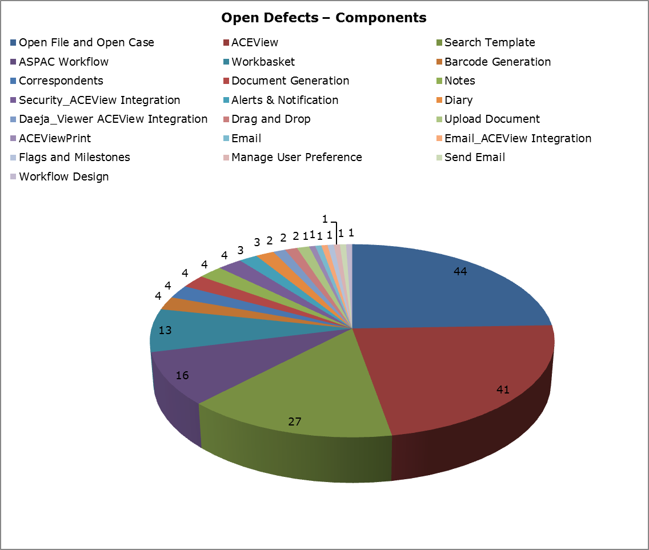

Note: All the open P3 defects are categorized based on the defect type and attached in the Appendix section. Also the Open defects list is available in the appendix section. Please refer appendix 5.3

## Closed Defects Summary

**Overall Defects Closure %:**

|  |  |  |  |
| --- | --- | --- | --- |
| **Fix Priority** | **Defect Logged** | **Closed Defects** | **Closure %** |
| 1 - Critical | 49 | 49 | 100% |
| 2 - High | 406 | 401 | 99% |
| 3 - Medium | 361 | 283 | 78% |
| 4 - Low | 155 | 58 | 37% |
| **Grand Total** | **971** | **779** | **80%** |

Note: The above closed defects count includes deferred defects.

**Defect Closure % - Priority wise Breakdown:**

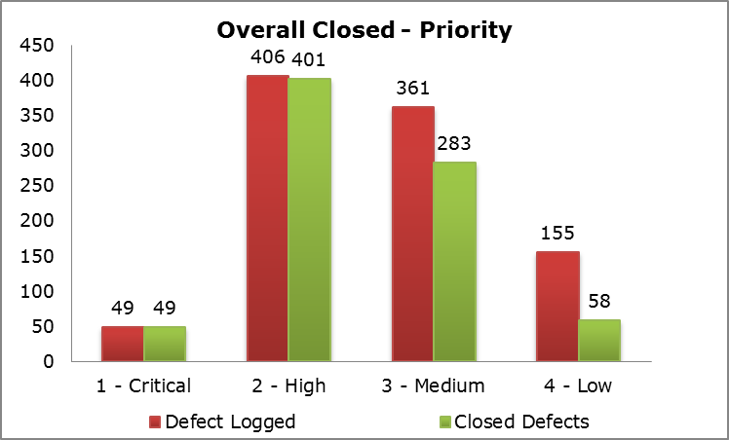

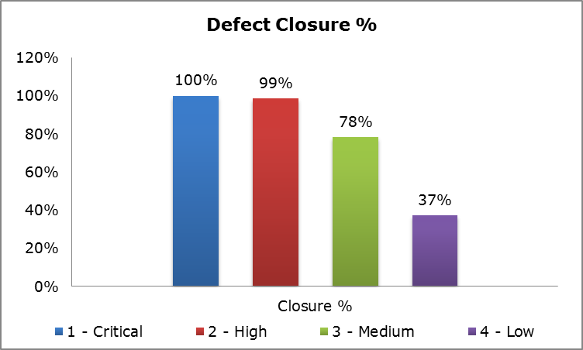

## Key Metrics

As part of ACE View ASPAC testing, the below tabulated Metrics are measured during the test execution phase of this project.

|  |  |  |
| --- | --- | --- |
| **Metrics** | **Formulae** | **Actual Result** |
| % Test Cases Executed | (Total Number of Test cases Executed)/ (Total Number of Test cases Planned)*100 | 100% |
| % Test Case Passed | (Total Number of Test cases Passed/  Total Number of Test cases Executed)*100 | 96.79% |
| % Test Case Failed | (Total Number of Test cases Failed)/ Total Number of Test cases Executed)*100 | 3.21% |
| % Test Case NA | (Total Number of Test cases NA)/ Total Number of Test cases Executed)*100 | 0.28% |
| Defect Discovery Rate | Total Number of Defects Reported/Total Number of Test cases Executed | 0.39 |

## Best Practices and Automation

**Best Practices Implemented:**

Automated smoke test pack was enabled in SIT for ASPAC below scenarios and the regression pack preparation is in progress.

* Automated Daily Quality Dashboard
* Automated ICC Audit Log Verifier
* Dynamic Screen Capture Tool
* Automated QC Utilities

**Automation Highlights:**

Regression test cases from the core components were automated.

**Components Automated**

* ASPAC Workflow – PO, T&E and CD creation.
* Workbasket – Perform Pend/Un Pend/Priority change
* Barcode Generation
* Notes-Alert/User/Diary
* ICC Component
* Verification of DataCap Scanned Documents in ACE View

# Test Deliverables

## Test Documents Delivered

|  |  |  |
| --- | --- | --- |
| **Test Phase** | **Deliverables** | **Path** |
| Test Strategy | Test Strategy | Reviewed and signed off |
| Test Design | Test Scenarios | http://uk01dqct004:8080/qcbin/start_a.jsp |
| Test Development | Test Cases | http://uk01dqct004:8080/qcbin/start_a.jsp |
| Test Execution | Test Log | http://uk01dqct004:8080/qcbin/start_a.jsp |
| Test Closure | Test Summary Report | In Progress. |

## Desktop Configurations

* VDI desktop used for testing with IE 8/IE11 browser and Java version xx.
* To enable ACE View Print, PDF Forge need to be installed in the desktop



* Save and Send add-in need to be installed in the desktop to test the save and send component.

 

* To enable Drag and Drop, the active-x available in the below share path need to be installed in the desktop

<https://officespace.aceina.com/s/Apollo2Symposium/General/Forms/AllItems.aspx?RootFolder=%2fs%2fApollo2Symposium%2fGeneral%2fApollo%20Refresh%20Program%2f04%20Release%201%2f06%20Technical%20Design%2f06%20Drag%20n%20Drop%20ActiveX%20Component&FolderCTID=0x012000B7F9EC70C9752B4DA37DF18AA4F04B81#InplviewHash63698f83-c9c8-44f4-a5e9-560c9c24594e>

**Application was tested in the below mentioned Configurations:**

|  |  |  |  |
| --- | --- | --- | --- |
| **IE Version Coverage** | **Java Version Coverage** | | |
| **Java 1.6.0-b105** | **Java 1.7.0_67-b01** | **Java 1.8.0_31-b13** |
| **IE8** | Full | Full | Limited |
| **IE9** |  | Limited |  |
| **IE11** |  |  | Limited |

## Environmental Challenges

The below items listed are environmental observations as part of SIT and **these issues are closed.**

|  |  |  |
| --- | --- | --- |
| **S. No** | **Components** | **Issues** |
| **1** | ICC (Email Broker) | After every build / patches update, the ICC server automatically restarted without any notification. Due to this, the emails were not processed when the server is down. |
| **2** | Barcode Generation and Document Generation | The barcode files are not getting generated as the services need to be restarted frequently. |
| **3** | Send Email / Send Fax | Junk values will be populated in the emails without the proper document attachment. |
| **4** | Drag & Drop | The drag & drop functionality will throw error (permission related) after the deployments. |

## UAT Support from SIT

* Test team would test all the defects in the SIT environment that are deployed in the UAT environment
* **Regression Testing** in SIT for the SIT and UAT defect fixes
* Test Team would update the root causes of the all the UAT defects
* Below mentioned RCA values will be updated in the root cause field by the Test team
  + Requirement Gap
  + Environment Issue
  + Training Issue
  + QA Miss/ Test Coverage issue in SIT
  + Working in SIT
  + Duplicate - Defect Exist in SIT

Note: While logging defects the Business needs to choose ASPAC - UAT as environment

# Appendix

## Usecases Test execution Summary



## CR Test execution Summary



## UI Imperfections



## Open Defects



All P3 open defects were tabulated below. *(Will be updated based on the defect closure)*

*P3 Defects Summary:*

|  |  |
| --- | --- |
| **Defect Type** | **# Defects** |
| Data | 10 |
| Error Message | 7 |
| Workflow | 1 |
| UI | 16 |
| Functional | 40 |
| Filter | 4 |
| **Grand Total** | **78** |

|  |  |  |  |
| --- | --- | --- | --- |
| **Defect ID** | **Defect Type** | **Summary** | **Component Name** |
| 139 | UI | ACEViewPrint : The original filename is not getting displayed in the convention <filename> rather smoother name is getting displayed, when original file is in the .tiff, .bmp, .png and .msg format. | ACEViewPrint |
| 147 | UI | Vega UI - The PO work basket names are not in sequence in Home Screen. | ASPAC Workflow |
| 295 | Error Message | ASPAC-Correspondent_ System does not display the warning message even if the maximum records returned is more than 1000 in the vendor search results | Correspondents |
| 330 | Data | Barcode - Values are not populated while typing values in 'Code' drop down field | Barcode Generation |
| 350 | Functional | ACEView - Barcode Generation: Not able to save the Barcode document into local desktop as Save button is in disable mode. | Barcode Generation |
| 368 | Functional | Search Template : No search results are displayed, in PO Invoice Quick search, when Wildcard search is performed. | Search Template |
| 373 | Error Message | WorkBasket_Mega Filter: When value entered in 'Payment Batch Amount from' is greater than value in 'Payment Batch Amount to', system does not throw an error message | Workbasket |
| 374 | Error Message | WorkBasket_Mega Filter: When value entered in 'Payment Batch Date from' is greater than value in 'Payment Batch Date to', system does not throw any error message | Workbasket |
| 377 | Filter | Workbasket_Mega Filter: Entering values for Mega filter and clicking on 'Apply to all workbasket' checkbox, the applied filter is not reflected in other work baskets. | Workbasket |
| 443 | Functional | Open File and Open Case: Right click on any folder in Tree view displayed only Attach Case, Detach case, Refresh and paste option. Attach Correspondents and Detach correspondents option is not displayed. | Open File and Open Case |
| 446 | Functional | Open File and Open Case : After selecting Multiple files and clicking on Attach button, only the lastly selected file is displayed in the Linked folder of Tree view. | Open File and Open Case |
| 447 | Functional | Open File or Open Case : Related cases option is not displayed on Right clicking the file which is linked to two or more work items. | Open File and Open Case |
| 476 | UI | Open File and Open Case: System is not displaying a visual indicator when a Priority is changed/Set for a work item. | Open File and Open Case |
| 536 | UI | Manage User Preference : In General settings, Default Calendar type drop down is not working as expected. | Manage User Preference |
| 569 | Filter | Workbasket_MegaFilter: System allows the user to save the filter even for all the workbaskets under the 'PO Invoice' workbasket. | Workbasket |
| 570 | Functional | ASPAC Workflow: In Open status work item of Citi Direct Payment, Comment text field is not getting displayed | ASPAC Workflow |
| 596 | Data | Barcode Generation : Invalid values are getting displayed in "Code" dropdown in Barcode geneartion page. | Barcode Generation |
| 598 | Functional | Alerts and Notifications : No notification is displayed by the system when an alert is set by the user. | Alerts & Notification |
| 601 | Error Message | ASPAC Workflow : The error message is not same when selected "Approve Order" from workbasket "Actions" Vs "Case Actions" after opening the workitem | ASPAC Workflow |
| 605 | Functional | Open File and Open Case: The system allows to attach a workitem that has already been attached | Open File and Open Case |
| 606 | Functional | Open File and Open Case: "View Related Files" option is not avialable in the application | Open File and Open Case |
| 612 | Data | Open File Open Case : System not displaying the correct value in the Ingestion Type column when the documents in work item is exported to the local drive in a CSV format. | Open File and Open Case |
| 616 | UI | There is no checkbox option for selecting multiple files in the Query Dialog box while performing Attach Case. | Open File and Open Case |
| 622 | UI | Undefined characters are displayed in the column header of the new tab after performing Data Export function in the document tab. | Open File and Open Case |
| 623 | UI | Document icon is missing in the new tab dialog box while performing Data Export action. | Open File and Open Case |
| 694 | Functional | Search Template : Performing search using criteria as "Note Search for File" in Search Template and "All" in Note type, no result is displayed. | Search Template |
| 697 | Data | Open File and Open Case: "Document Type" field values are not matched with the values in configuration document. | Open File and Open Case |
| 700 | Functional | Open File and Open Case: After linking a PO,CD and T&E documents to a document and clicking on "New File" button, "PO Invoice","CitiDirect Payment" and "T&E Expense" options are not enabled. | Open File and Open Case |
| 729 | Functional | Flags and Milestones Tab: Flags and Milestones Tab can be saved after adding comments, without entering and saving datas in PO Invoice Tab | MI Reports |
| 734 | UI | Search Template : Mismatch in the Document Search template fields displayed in ACEView and Config Sheet | Search Template |
| 741 | Functional | Email_ACEView Integration: 'Document' count mismatch in the 'Indexing' tab for Test-2 Multi attachment Scenario | Email_ACEView Integration |
| 760 | Data | Correspondents : Only some of the field values are getting displayed in Correspondent tab. | Correspondents |
| 764 | Functional | Open File and Open case : By default Exported data are getting saved in .CSV format | Open File and Open Case |
| 766 | Data | Search Template: "File number" column is blank for some documents in "Document Search" results | Search Template |
| 767 | Data | Search Template: "Security Policy" column is blank for some search results and displays number for some results in "Document Search" | Search Template |
| 769 | Data | Search Template: "Ingestion Info" column displays wrong values for some search results in "Document Search". | Search Template |
| 770 | Functional | System displays inconsistent behaviour while saving a "PO Invoice" without entering mandatory values in "PO Document" tab and "Cost Allocation" tab | ASPAC Workflow |
| 772 | Data | Search Template: System does not display any value in "File Type" column for results belong to Finanace Indexing workitem | Search Template |
| 776 | Functional | Drag and Drop: Unable to drag and drop a document from Sharepoint into the ACEView. | Drag and Drop |
| 786 | Functional | Search Template : Mismatch in the Deleted Document Search template fields displayed in ACEView and Config Sheet | Search Template |
| 801 | Functional | OA limit has not been set for the Business unit of Macau but the Higher approval list is getting displayed. | ACEView |
| 851 | Filter | Open file and Open case: There is no option available to set any Default filter for 'Document note', 'File note' | Open File and Open Case |
| 854 | UI | Index Document : After indexing a Document, "Document Indexed" icon is not visible. | Open File and Open Case |
| 856 | UI | ACEView : Whenever user Hover over a User's LAN ID system should display the User's Full Name and vice versa.But system does not display User's Full Name in Document panel. | ACEView |
| 859 | UI | ACEView : The System Environment (i.e. DEV, SIT, UAT or PRD), and the Version of the Release (i.e. 1.0), must be displayed on an area that is visible from all pages of the application, e.g. in the Browser Title Bar.But it is not displayed. | ACEView |
| 861 | Functional | Open File and Open Case : Data Export - Export only visible columns is exporting all columns. | Open File and Open Case |
| 864 | UI | ACEView : In Document panel, tool tip showing the data in the cell is not displayed for columns. | ACEView |
| 868 | Functional | Document Notes: Document Notes is not added when a document is Exported and Sent by Email. | Notes |
| 873 | Functional | Open file and Open case_Attach Case: After linking two files, User is unable to open the File-B' from 'File-A' in both '2-way' and '1-way' link type | Open File and Open Case |
| 880 | Functional | Open File and Open case : File Type and Folder Type are not copied when copying a document from one workitem to another workitem. | Open File and Open Case |
| 884 | Functional | Document Actions: Document properties copied displays Number '2' for 'Document Type' field when clicking on 'Document Send' from 'Document Actions'. | ACEView |
| 897 | UI | ACEview: All the 'Columns headers' are not available for filtering the Search results | ACEView |
| 903 | Workflow | ASPAC workflow : System allow to Re-assign CD workitem to PO Processor where the PO Processor has no access to "Citidirect Payment approval" workbasket. | ASPAC Workflow |
| 904 | Functional | Open File & Open Case: When Copying across Files with the same Document Taxonomy, the copied document from File A is not getting copied under Document type of File B. | Open File and Open Case |
| 906 | Functional | Open File & Open Case: When Copying document across Files with the different Document Taxonomy, Document type of File A is not getting changed to Document type of File B. | Open File and Open Case |
| 929 | Functional | Search Template : Cost Allocation search is not displaying proper results when contain filter is used to retrive result | Search Template |
| 930 | Functional | Daeja Viewer_Annotations: Document annotations is not getting retained when the document is moved to another file using 'Move' action. | ACEView |
| 932 | Functional | Document Notes: There is no option for user to add note from ‘Document Indexing Panel’ | Notes |
| 933 | Functional | Document Indexing: In ‘Auto-Fill’ action, even the ‘Document Description’ field is copied to the next file. Unable to differentiate/demarcate multiple files if it has same description | ACEView |
| 942 | Functional | Search Template: Search results are not displayed when "Note Type" field is selected as "All" . | Search Template |
| 951 | UI | ASPAC Workflow : For "Invoice Arrived" status, "Department" field is mandatory.But it is read only field in "Goods Arrived" status. | ASPAC Workflow |
| 956 | Data | Search template : Alt account dropdown values are not getting populated | Search Template |
| 967 | UI | Search template : The value File type is not getting displayed in search result for "Deleted Document search" template. | Search Template |
| 970 | Functional | Index Document : Unable to edit document description of the child document under a batch. | Open File and Open Case |
| 976 | Filter | Workbasket Mega Filter : Transaction type/Transaction file type/Transaction count should be displayed under "Filters" header in Mega filter. | Workbasket |
| 977 | Functional | Security_ACE View Integration: User is getting multiple mail triggers for the same work item when a user assigning a BU in Work basket Email notification in Settings icon. | Security_ACEView Integration |
| 980 | Error Message | ASPAC Workflow: System is displaying Mandatory Error message for 'Requestor' field while performing the action 'Send Invoice for Coding' | ASPAC Workflow |
| 981 | Functional | ASPAC Work Flow : On opening PO with status “Closed created in Error”, buttons in the Document Panel are in disable mode. | ASPAC Workflow |
| 984 | Functional | ASPAC Work Flow : On opening PO with status “Closed created in Error”, Data Export button is not working as expected for Package documents. | ASPAC Workflow |
| 988 | Functional | ASPAC Work Flow: On opening PO with status “Closed created in Error”, Move option is displayed upon right click on the document. | ASPAC Workflow |
| 1002 | Functional | Open file/Open case : System does not allow to Open selected workitem via Action list in workbasket. | Open File and Open Case |
| 1003 | Functional | Daeja Viewer: Bookmark added to a document in ACEView is getting applied to the document opened in Daeja Viewer using "Open Document" option available in the viewer. | Daeja_Viewer ACEView Integration |
| 1006 | Functional | Send Email : Mismatch in the document name attached in Outlook and the document name available in ACE view - Document List | Send Email |
| 1007 | UI | Search Template: User must have the option of opening the Document directly via “document search” | Search Template |
| 1009 | Error Message | ACE View: System displays the popup message in the bottom of the screen inconsistently, when the user tries to login the application in IE 11. | ACEView |
| 1020 | Functional | Search Template: Search results are not getting displayed based on search criteria “Invoice No”. | Search Template |
| 1022 | Functional | Notes : There is no option available to Unindex and Unlink a document in ACE View system. | Notes |
| 1058 | Error Message | Open file and Open Case : System is not throwing error message on giving digits as input in User textbox while reassigning a work item. | Open File and Open Case |

**IE11 Known issues:**

Pagination does not work in IE11

Full content of the workbasket is not displayed by working on actions-IE11

System crashing (Not consistent) when performing actions in IE 11

# Reference Documents

## Requirement Document

**Global Requirement Document:**

<https://officespace.aceina.com/s/Apollo2Symposium/General/Forms/AllItems.aspx?RootFolder=%2Fs%2FApollo2Symposium%2FGeneral%2FApollo%20Refresh%20Program%2F04%20Release%201%2F02%20Wave%201%20and%202%20Business%20Requirements%2F01%20Global%20Requirements&FolderCTID=0x012000B7F9EC70C9752B4DA37DF18AA4F04B81&View=%7B63698F83%2DC9C8%2D44F4%2DA5E9%2D560C9C24594E%7D>

## Usecase Document:

**ASPAC usecases:**

<https://officespace.aceina.com/s/Apollo2Symposium/General/Forms/AllItems.aspx?RootFolder=%2Fs%2FApollo2Symposium%2FGeneral%2FApollo%20Refresh%20Program%2F04%20Release%201%2F03%20Wave%201%20and%202%20Functional%20Design%2F07%20Wave%201%20Functional%20Design%2F03%20Wave%201%20Use%20Cases%2F01%20ASPAC%2F02%20Use%20Cases%2F01%20Baselined&FolderCTID=0x012000B7F9EC70C9752B4DA37DF18AA4F04B81&View=%7B63698F83%2DC9C8%2D44F4%2DA5E9%2D560C9C24594E%7D>

**Core usecases:**

<https://officespace.aceina.com/s/Apollo2Symposium/General/Forms/AllItems.aspx?RootFolder=%2Fs%2FApollo2Symposium%2FGeneral%2FApollo%20Refresh%20Program%2F04%20Release%201%2F03%20Wave%201%20and%202%20Functional%20Design%2F06%20Core%20Functional%20Design%2F02%20Core%20Use%20Cases%2F03%20Baselined%20Use%20Cases&FolderCTID=0x012000B7F9EC70C9752B4DA37DF18AA4F04B81&View=%7B63698F83%2DC9C8%2D44F4%2DA5E9%2D560C9C24594E%7D>

## CR Document:

**Change Request Documents:**

<https://officespace.aceina.com/s/Apollo2Symposium/General/Forms/AllItems.aspx?RootFolder=%2Fs%2FApollo2Symposium%2FGeneral%2FApollo%20Refresh%20Program%2F04%20Release%201%2F01%20Program%20and%20%20Project%20Management%2F03%20Change%20Management>